Q1) Create a table “STATION” to store information about weather
observation stations:

SOLUTION: - query input
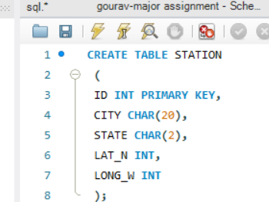

Q2) Insert the following records into the table
Solution-
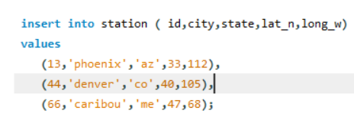

Q3) Execute a query to look at table STATION in undefined order.
Solution: -
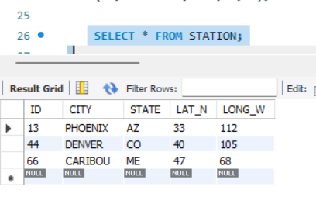

Q4) Execute a query to select Northern stations (Northern latitude > 39.7).
Solution: -
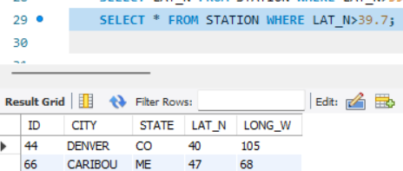

Q5) Create another table, ‘STATS’, to store normalized temperature and precipitation data:
There will be no Duplicate ID and MONTH combination
Solution; -
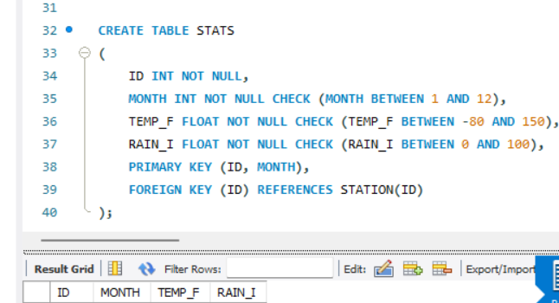

Q6) Populate the table STATS with some statistics for January and July

Solution: -

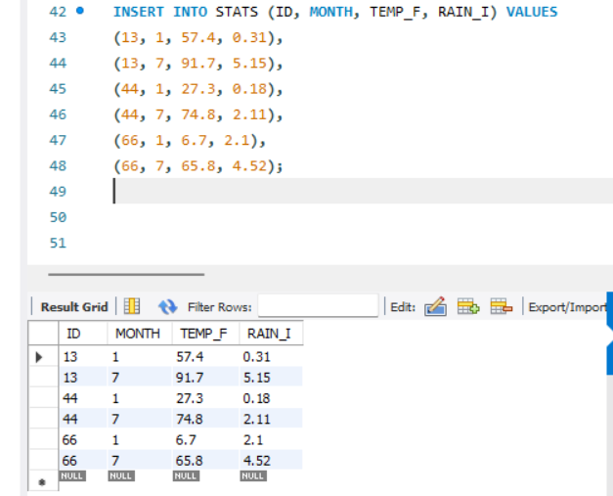

Q7) Execute a query to display temperature stats (from the STATS table) for each city (from the STATION table).
Solution: -
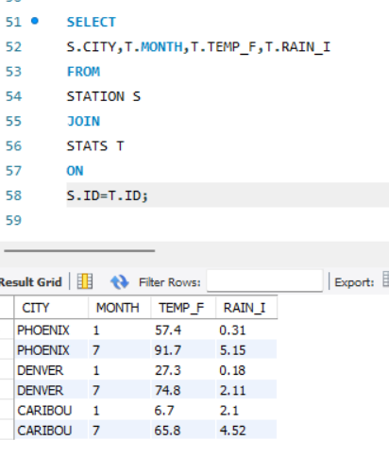
Q8) Execute a query to look at the table STATS, ordered by month and greatest rainfall, with columns rearranged. It should also show the corresponding cities.
Solution: -
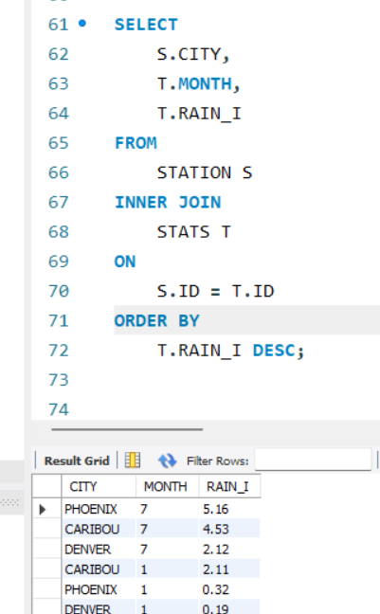

Q9) Execute a query to look at temperatures for July from table STATS, lowest temperatures first, picking up city name and latitude.
Solution:-
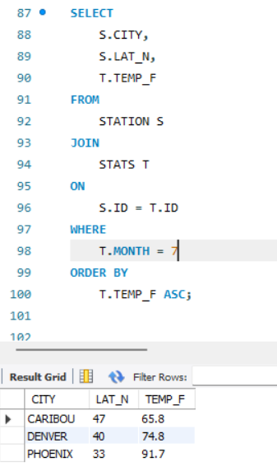

Q10) Execute a query to show MAX and MIN temperatures Aswell as average rainfall for each city.

Solution: -

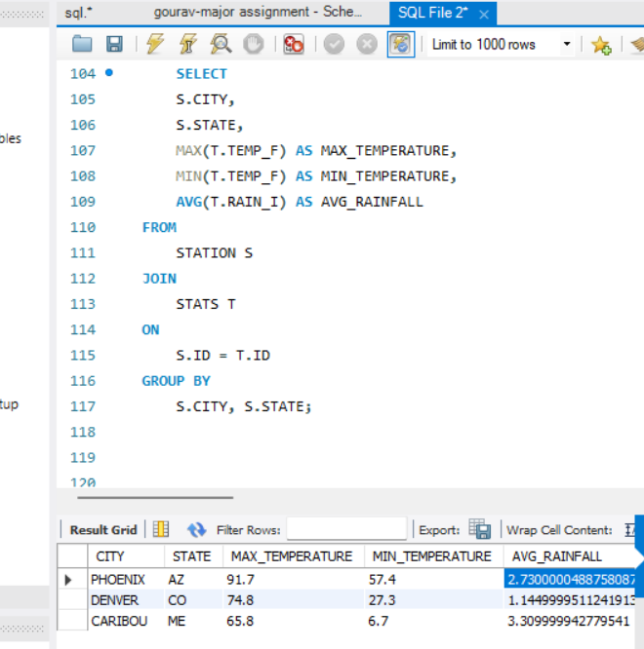

Q11) Execute a query to display each city’s monthly temperature in Celsius and rainfall in Centimetre.

Solution; -
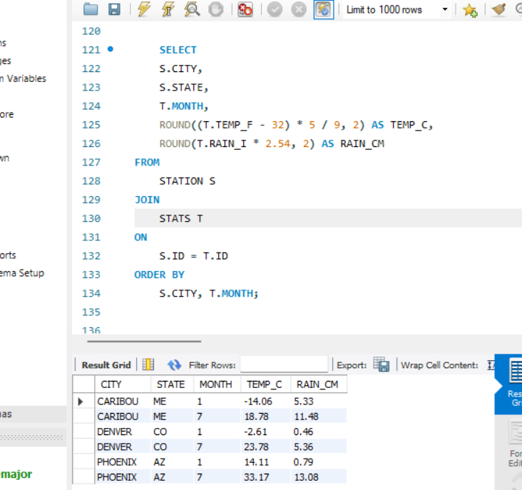

Q12) Update all rows of table STATS to compensate for faulty rain gauges known to read 0.01 inches Low.
Solution; -

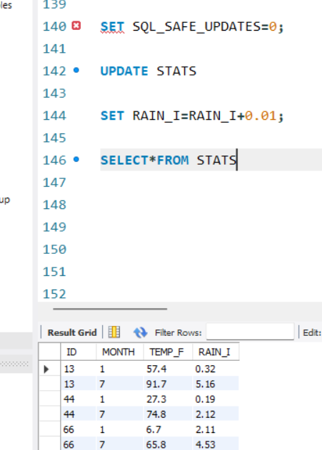

Q13) Update Denver's July temperature reading as 74.9
Solution; -

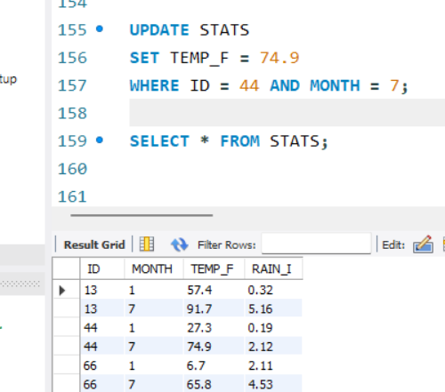

THANK YOU

